
Montessori Senior Secondary School
A-Camp, Kurnool.
Montessori Smart Learning Resource Management System (MSLRMS)
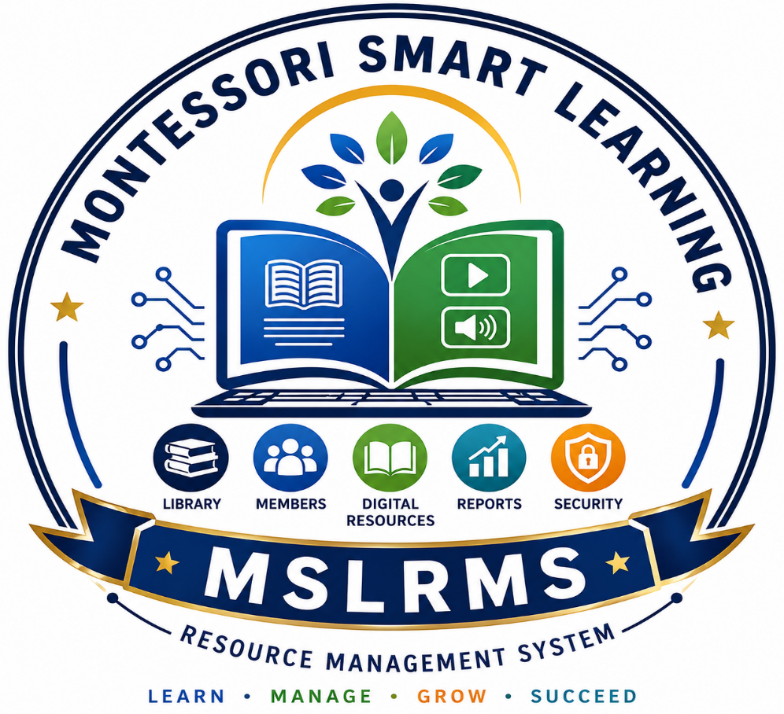
Project Documentation

Developed By
K. S. Nanda Kishore
PGT in Computer Science

The Montessori Smart Learning Resource Management System (MSLRMS) is an integrated Library and Digital Learning Management System developed specifically for educational institutions.
Unlike conventional library software, MSLRMS combines:
- Physical Library Management
- Digital Library
- Student Reading Portal
- QR Code Technology
- Barcode Technology
- Smart Search
- Reports & Analytics
- Student Engagement
into a single application.
The system helps schools efficiently manage physical books, digital resources, student borrowing, library visits, and educational content using modern technologies.
Vision
To create a paperless, technology-driven, smart library that promotes digital learning and lifelong reading habits among students.

Advantages
- Easy to use
- Paperless operation
- Fast searching
- Digital learning support
- Student engagement
- Secure system
- Barcode enabled
- QR enabled
- Multi-format support
- Offline LAN compatible
- Scalable architecture
Security Features
- Password Authentication
- Role Based Access Control
- Session Expiry
- Secure File Upload
- File Validation
- SQLAlchemy ORM Protection
- Protected Downloads
- Login Authorization

Future Enhancements

- AI Book Recommendation
- AI Chatbot
- Mobile Application
- Android App
- Parent Portal
- SMS Notifications
- WhatsApp Alerts
- Cloud Synchronization
- Multi-school Management
- AI-based Reading Analytics
- Voice Search
- Digital Attendance Integration

Mission
- Digitize school library resources
- Encourage reading culture
- Provide anywhere access to learning materials
- Reduce manual work
- Improve resource utilization

Objectives
- Automate library operations
- Reduce paperwork
- Enable digital learning
- Improve book tracking
- Generate reports instantly
- Increase student engagement
- Provide secure access to resources

System Overview
MSLRMS consists of two major sections.

Physical Library

- Book Catalogue
- Members
- Issue/Return
- Renewals
- Fine Management
- Lost Books
- Donations
- Stock Verification
- Barcode Generation
- QR Code Generation

Digital Library
Supports multiple formats:
- PDF DOC DOCX PPT
- PPTX MP3 WAV MP4

Features include:
- Smart Search
- OCR Search
- Category Search
- Subject Search
- QR Code Access
- Online Reading
- Audio Streaming
- Video Streaming

Technology Stack
Component | Technology
Programming Language | Python
Backend Framework | Flask
Database | SQLite
ORM | SQL Alchemy
Frontend | HTML5
Styling | CSS3
Client-side | JavaScript
Authentication | Flask Login
QR Code | qrcode
Barcode | python-barcode
OCR | Tesseract OCR
PDF Processing | pdfplumber
Office Processing | python-docx, python-pptx
Deployment | Windows Standalone (.exe)

User Roles

Administrator
- Manage all users
- Manage books
- Manage members
- Manage digital library
- Generate reports
- Configure system
- Backup database

Librarian
- Add books
- Issue books
- Return books
- Fine collection
- Member management
- Visitor Register

Student
Login using
Admission Number &
Password: Date of Birth
Students can
- Read online books
- Bookmark books
- Favourite books
- Read history
- Earn points
- Receive certificates
- View recommendations

Major Modules

1. Authentication Module
- Login
- Logout
- Role Management
- Student Auto Login Creation
- Session Management

2. Book Management
Features
- Add Book
- Edit Book
- Delete Book
- Barcode Generation
- Rack Number
- Subject Classification
- Availability Tracking

3. Member Management
Supports
Students
Staff
Stores
- Admission Number
- Parent Phone
- DOB
- QR Code

4. Circulation Module
- Issue Book
- Return Book
- Renewal
- Due Date Calculation
- Fine Calculation
- Overdue Detection

5. Fine Management
Automatic
₹2/day fine calculation
Tracks
Pending
Paid
Collection History

6. Lost Book Register
Stores
- Lost Date
- Member
- Cost
- Remarks

7. Stock Verification
Maintains
Present
Missing
Damaged
8. Visitor Register
Records
Visitor
Purpose
Check-in
Check-out

9. Donation Register
Tracks
Donor
Book
Quantity
Donation Date

Digital Library
One of the most innovative modules.

Supports:
- eBooks
- Question Papers
- Notes
- Assignments
- Videos
- Audio Books
- Reference Material

Features include:
- Smart Search
- Subject Filtering
- Category Browsing
- QR Code Access
- Preview
- Download
- Streaming
- Bulk Import

Student Engagement
Students receive
- Reading Points
- Bookmarks
- Favorites
- Recently Read
- Recommendations
- Reading History
- Digital Certificates
This transforms the library into a learning platform rather than merely a book repository.

Dashboard & Analytics
Displays

- Total Books
- Available Books
- Issued Books
- Lost Books
- Members
- Overdue Books
- Fine Collection
- Subject-wise Distribution
- Monthly Issue Statistics
- Most Borrowed Books

Database Design
Major Tables

- Users
- Books
- Members
- Issues
- Fine Payments
- Lost Books
- Stock Verification
- Periodicals
- Visitors
- Donations
- Online Books
- Bookmarks
- Favourites
- Read History
- Certificates
- Digital Library Visits

Conclusion
The Montessori Smart Learning Resource Management System (MSLRMS) is a comprehensive school library automation and digital learning solution that integrates physical library management with modern digital education tools. It streamlines library operations, enhances student engagement, supports secure resource management, and provides data-driven insights for administrators.
With its offline LAN capability, multi-format digital repository, smart search, QR/barcode integration, and scalable architecture, MSLRMS is well-suited for schools seeking a future-ready library ecosystem.

